Summary Report of PeSeTo Seminar 2023 in Tokyo

PeSeTo seminar titled “Public health practice, policy, and research in the post-corona era in East Asia” was successfully held in the Medical Library Conference Room 333 in Hongo Campus of the University of Tokyo on the afternoon of 16th December 2023.

PeSeTo started in the initiative of Professor Emeritus Seung Wook Lee of Seoul National University SPH in 2008. Since then, three schools of public health jointly addressed common public health issues and challenges in East Asia, such as population ageing, emerging health crisis, health inequality, and cross-border environmental problems.

Facing our common challenge of the COVID-19 pandemic, the University of Tokyo hosted an online PeSeTo special seminar in March 2021, where detailed and timely report of each country case facilitated mutual exchange of public health lessons for effective crisis management. Almost two years have passed, and PeSeTo 2023, the 9th conference, concluded the third cycle of PeSeTo exchange here in Tokyo with face-to-face meeting of core faculties.

Chaired by Dean Prof. Siyan Zhan of Peking University, the first session focused on Healthcare policy in the post corona era. The second session was chaired by Dean Prof. Hyojee Joung of Seoul National University to discuss on the issue of community and health promotion in post-corona East Asia. Finally, the last session addressed global and environmental health challenges chaired by Prof. Hashimoto of the University of Tokyo.

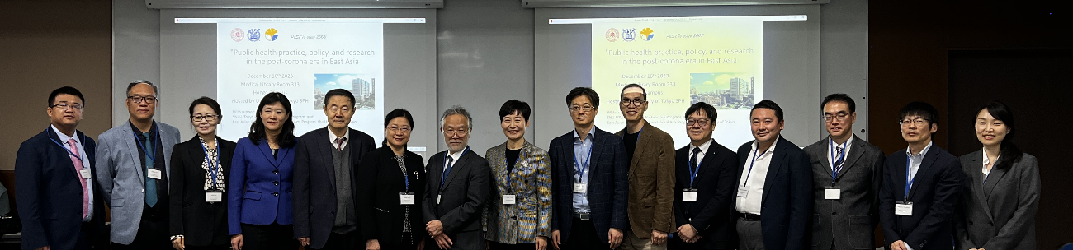

Photo of PeSeTo participants

From the left

Prof. Lu, Dr. Jian, Prof. Xu, Prof. Wang H, Prof. Wang PY, Dean Prof. Zhan (PKU participants)

Head Prof. Hashimoto (in the center)(UT)

Dean Prof Joung, Prof. Ko, Prof. Chung, Prof. Hwang (SNU participants), Dr. Nakazawa (UT), Prof. Yamamoto (SNU), Prof. Murakami and Dr. Kim (UT)